/***************************************************************************/

/* Name: Daniel Ackuaku */

/* Course: Engineering 304L */

/* Lab: Lab Number 3 */

/* Date: 21st February 2019. */

/***************************************************************************/

/* The ".text" assemlber directive indicates the beginning of the code section of the program */

.text

/*TEMPLATE: factorial function */

/* The ".global factorial" assembler directive exports the */

/* "factorial" label as an external symbol, so that C-Code can call it */

.global factorial

factorial: /* Starting location of the function */

/*************************FunctionTemplate*********************************/

/* Pseudo-code for this function is as follows

/* pop the top elemment from the stack

/* decrement the stack pointer (sp)

/* if n = 1,

/* return 1

/* else stroe the value of n

/* subtract 1 from n

/* repeat above steps

/* multiply n * (n-1)

/*

/* store each value of n in memory using a stack

/* increment the sp by 8

/*

**************************************************************************/

/*TEMPLATE: rename the function labels as desired below */

/*TEMPLATE: write the assembly function below */

FACTORIAL_INIT:

/* include any register pushes here */

addi sp, sp, -0x8

stw ra, 4(sp)

stw r16, 0(sp)

FACTORIAL_EXEC:

/*TEMPLATE: include main execution of the function here */

beq r4, r0, BASE_CASE

mov r16, r4

subi r4, r4, 1

call factorial

mul r2, r2, r16

br FOUND_N

BASE_CASE:

/*TEMPLATE: include any register pops here */

movi r2, 1

/* Note that there should only be one "ret" instruction in your function */

FOUND_N:

ldw r16, 0(sp)

ldw ra, 4(sp)

addi sp, sp, 0x8

ret /* instruction to return to the calling function */

.end /* the assembler throws away all text after this line */

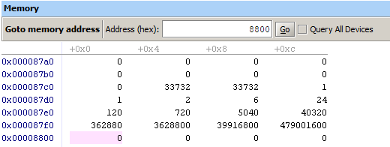

Figure . showing the results of the assembly code

Table A table containing the uses of the various registers in the program.

|  |  |
| --- | --- |
| Registers | Uses |
| r2 | Returns the value of factorial(n) |
| r3 | The location of the last data entry + 4 |
| r4 | Stores the current value of n when the recursive portion of the function is being carried out. |
| r7 | The location of the last data entry + 4 |
| r17 | The location of the current computation would be stored |
| r18 | The initial value entered into the factorial function |

Table A table showing the location and size of variables in the c code.

|  |  |  |
| --- | --- | --- |
| Variable | Register / Memory | Size in bytes |
| int Fact [13] | 087cc -0087f0 | (4*13) = 52 bytes |
| int n | r16 | N/A |